**BEFORE INSTALLING JENKINS , INSTALL JAVA -- sudo apt install openjdk-17-jdk (ALREADY INSTALLED IN THIS EC2 MACHINE )**

**INSTALL JENKINS**

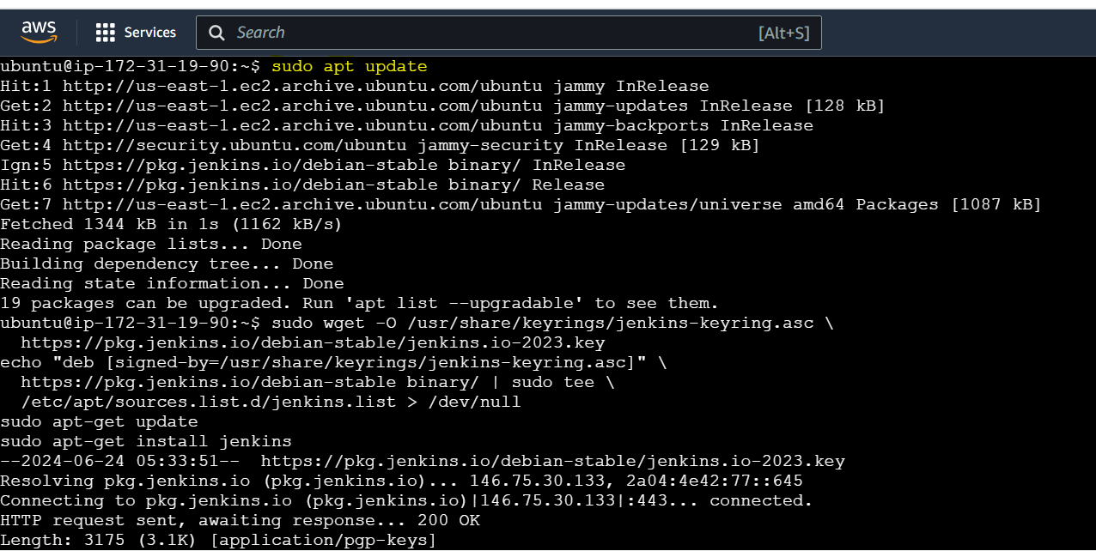

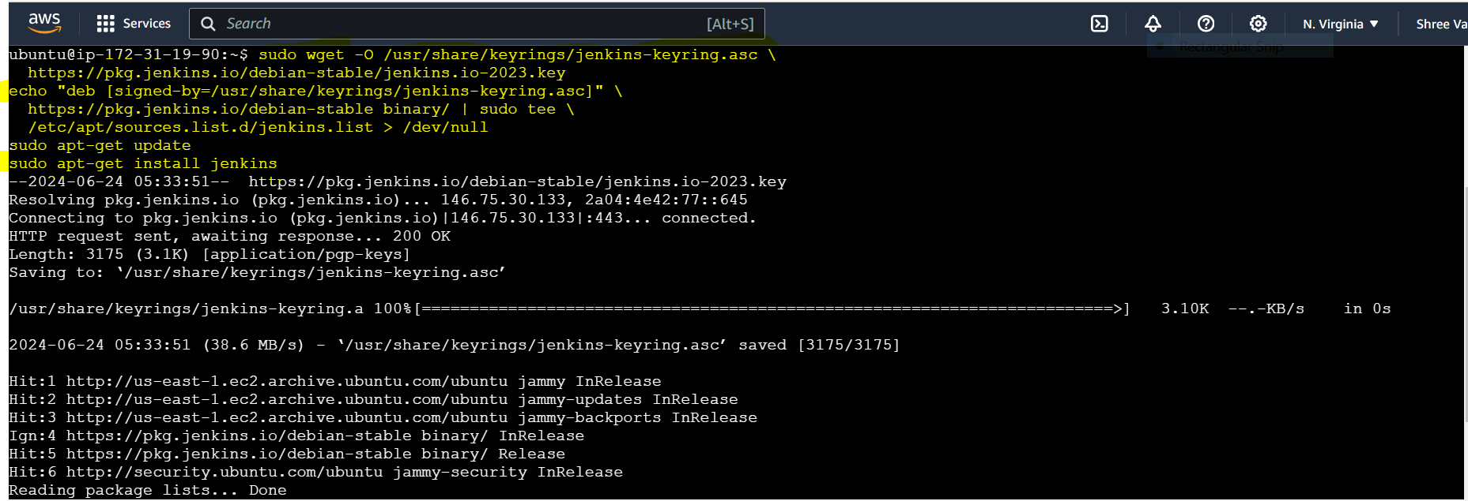

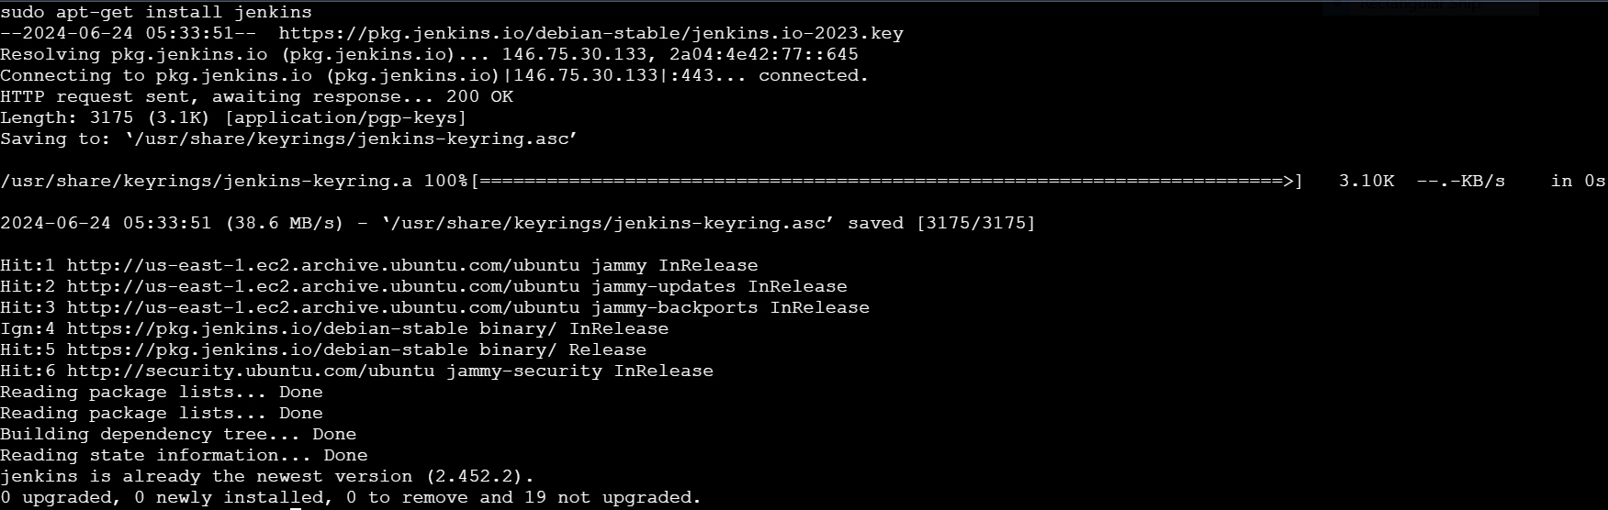

**NOW AFTER GIVING ACCESS TO PORT 8080 , COPY AND PASTE IP ADDRESS IN THE BROWSER:**

**MY IP ADDRESS**

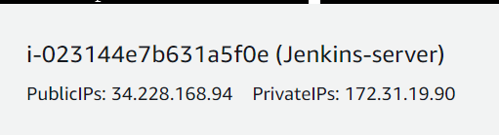

**JENKINS LOGIN**

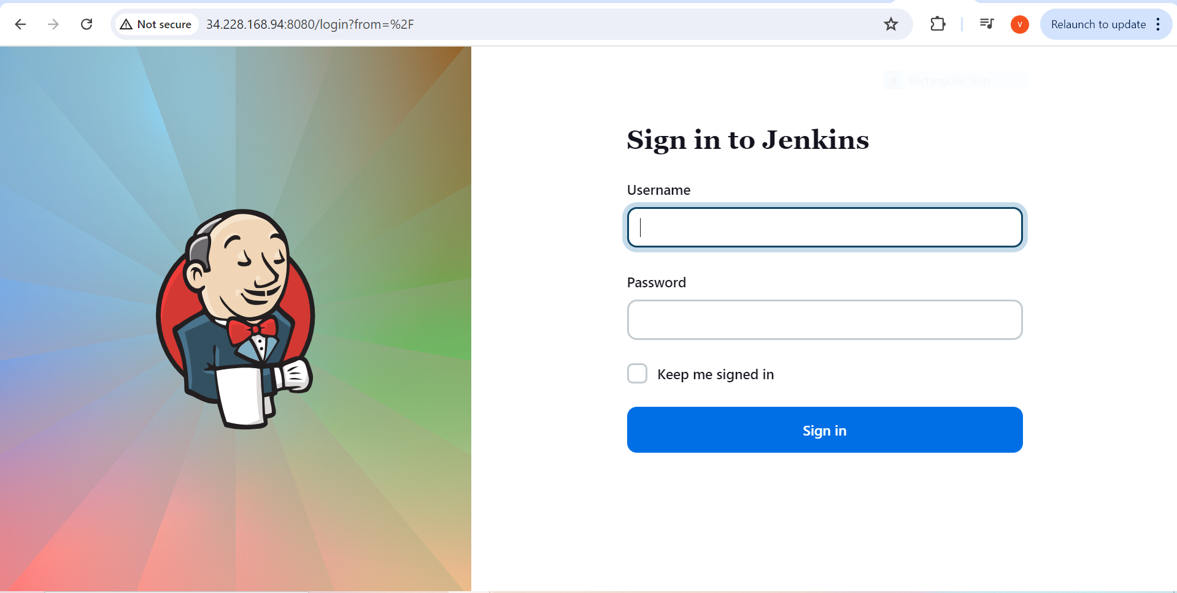

**CREATE A NEW JOB (FREESTYLE PROJECT)**

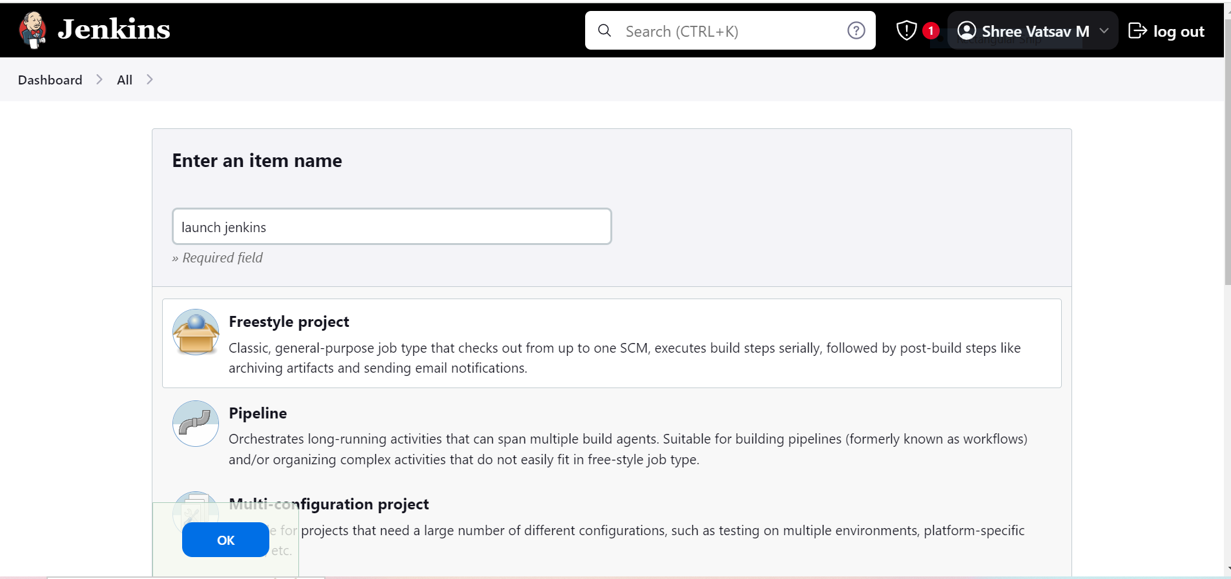

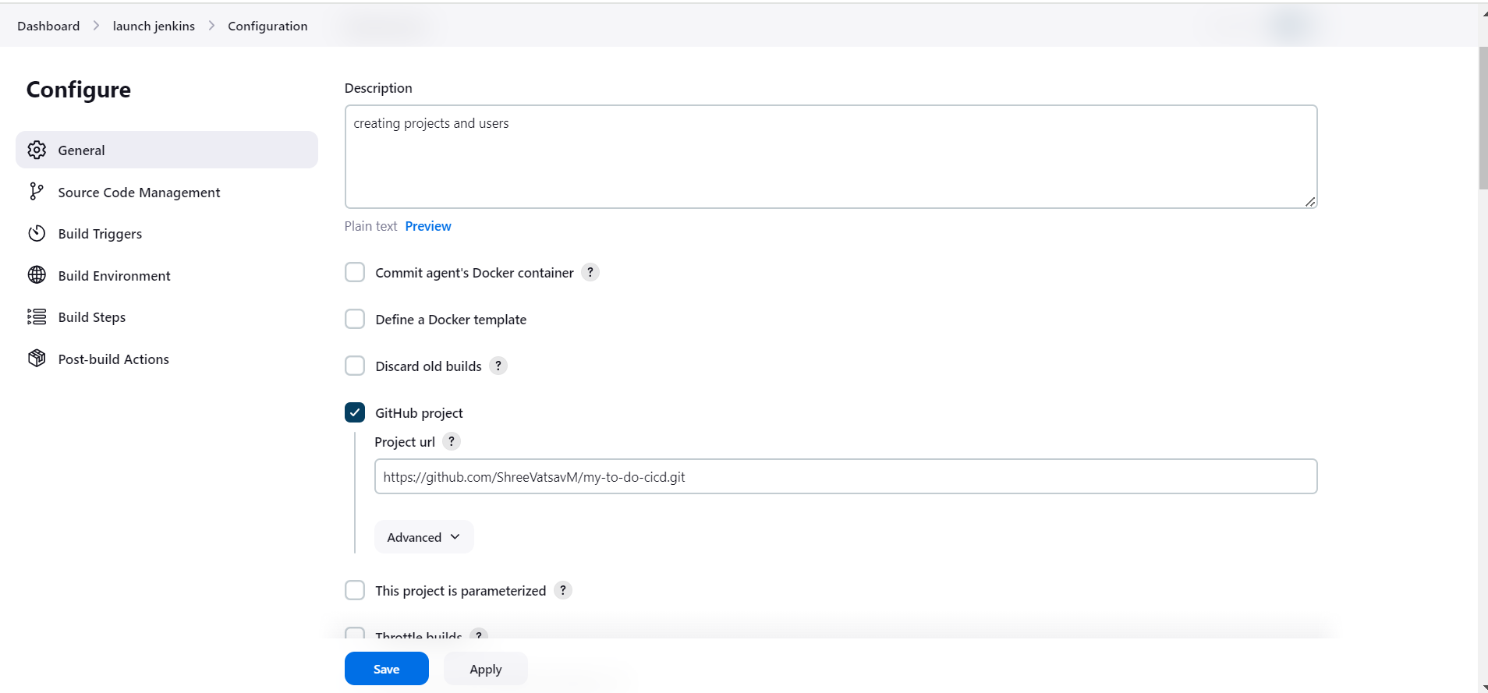

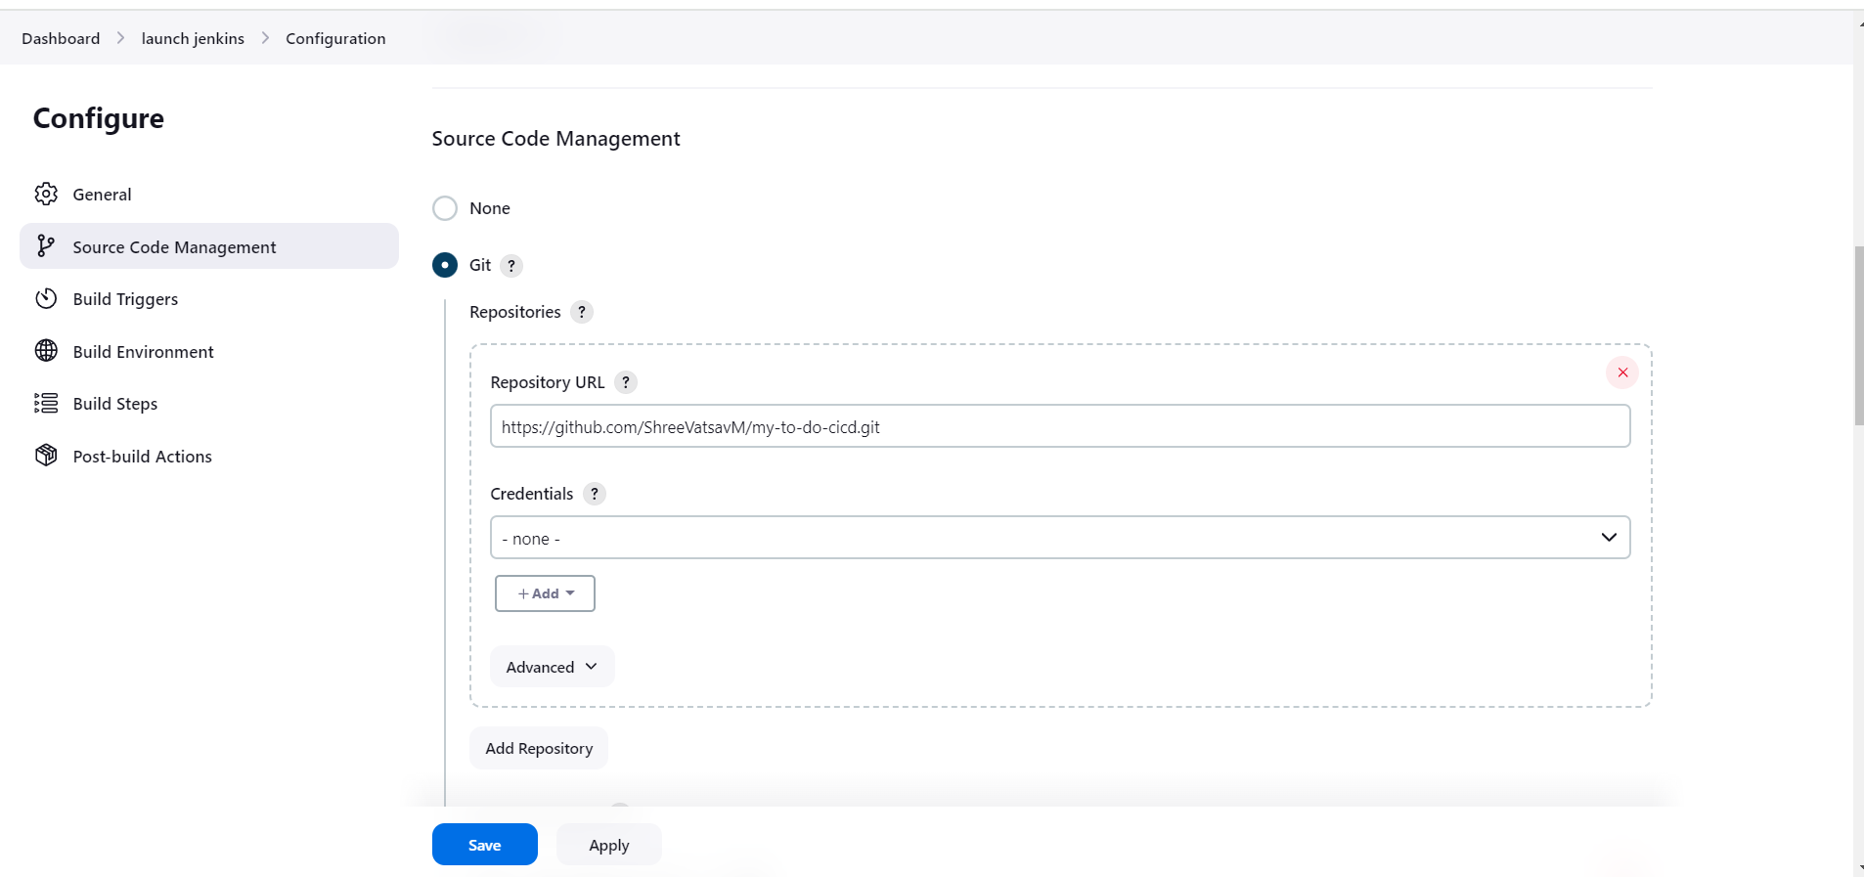

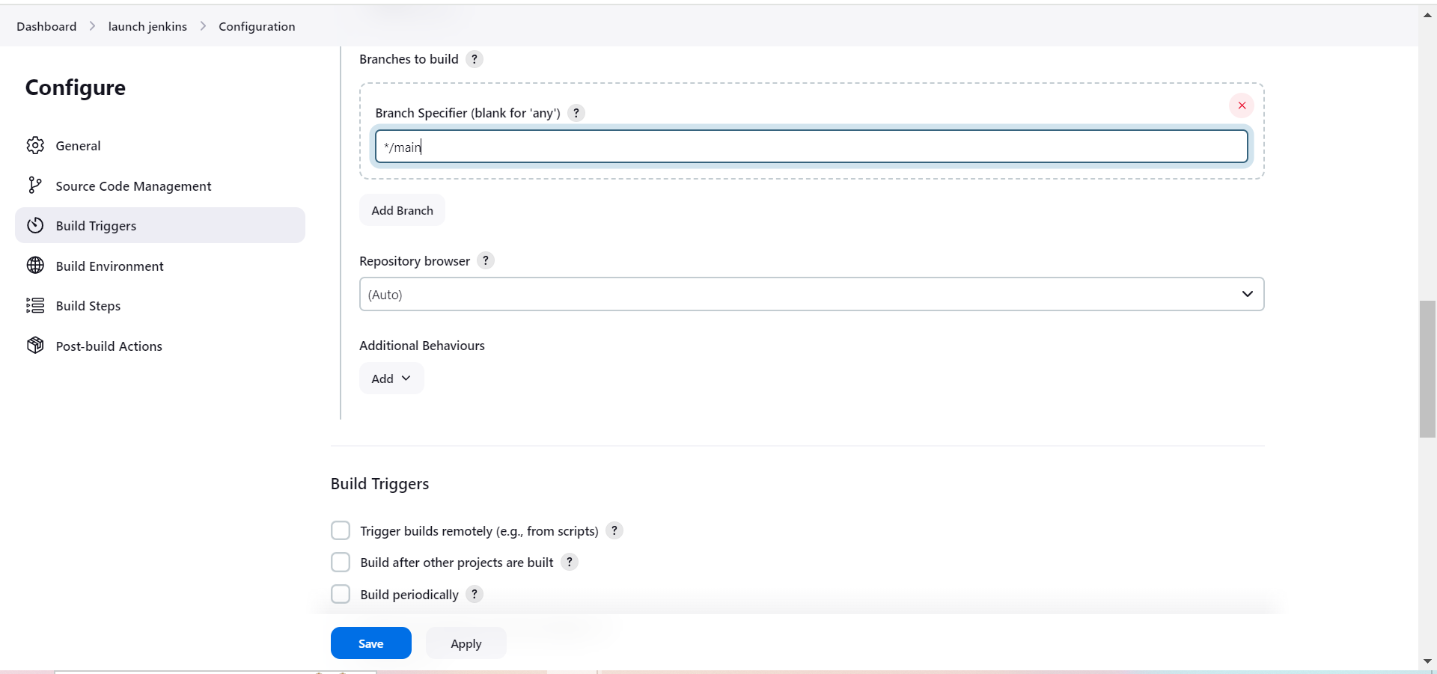

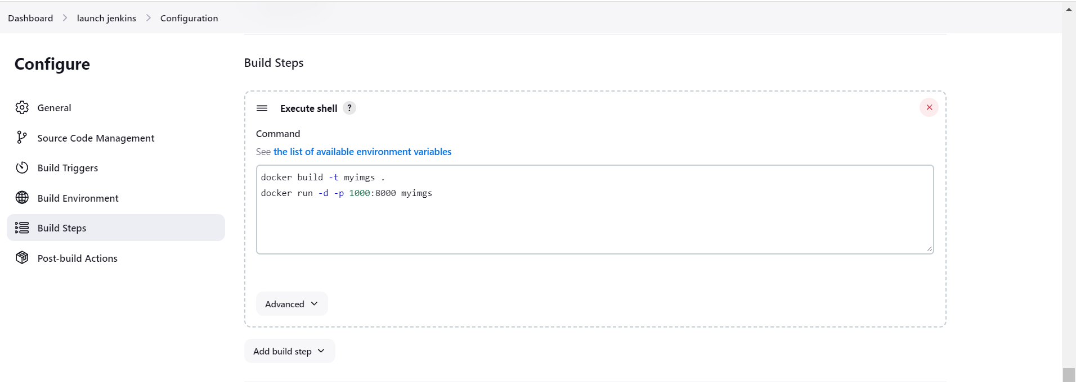

**ADDING USERS**

**NAVIGATE TO USERS UNDER SECURITY**

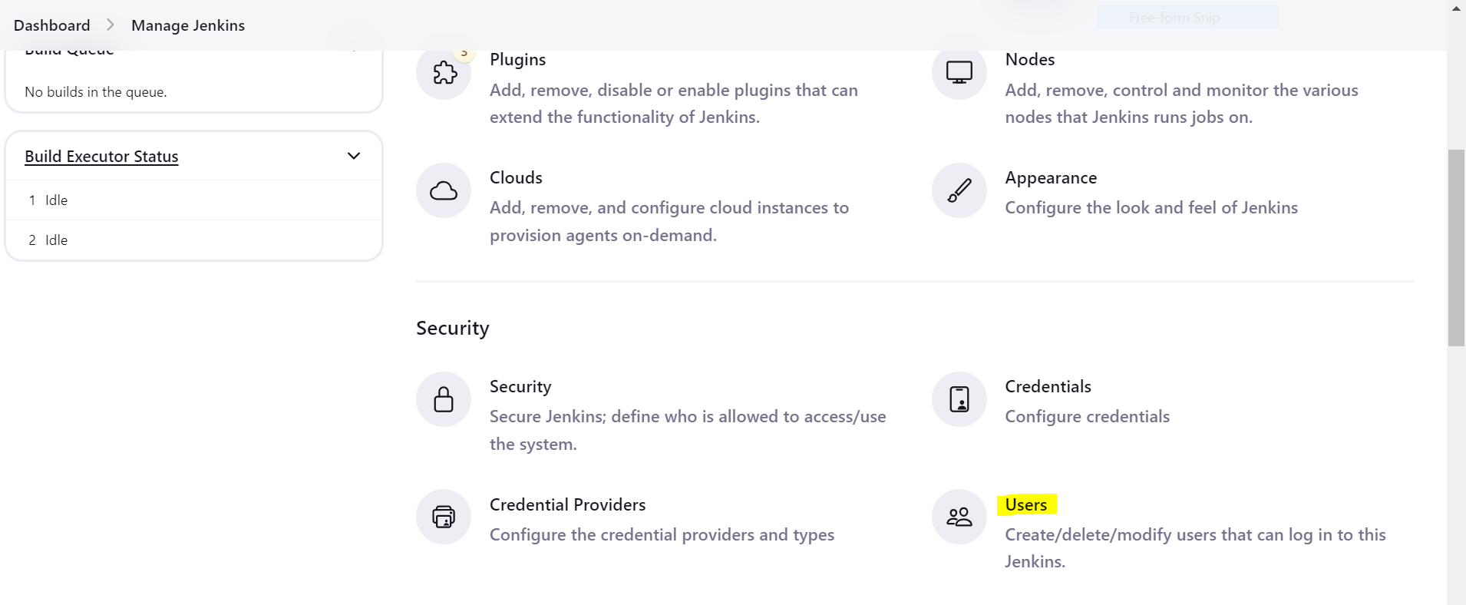

**CLICK CREATE USER**

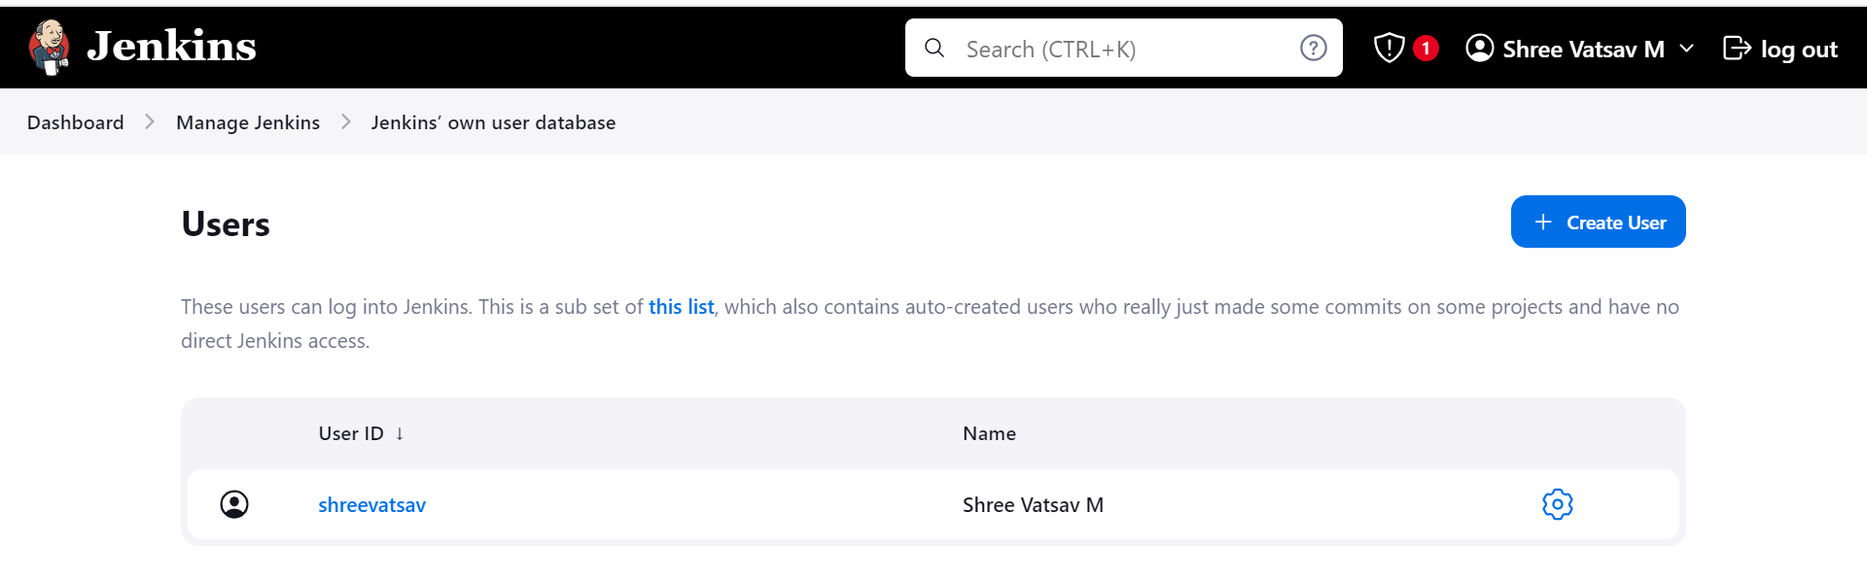

**ENTER THE USER DETAILS**

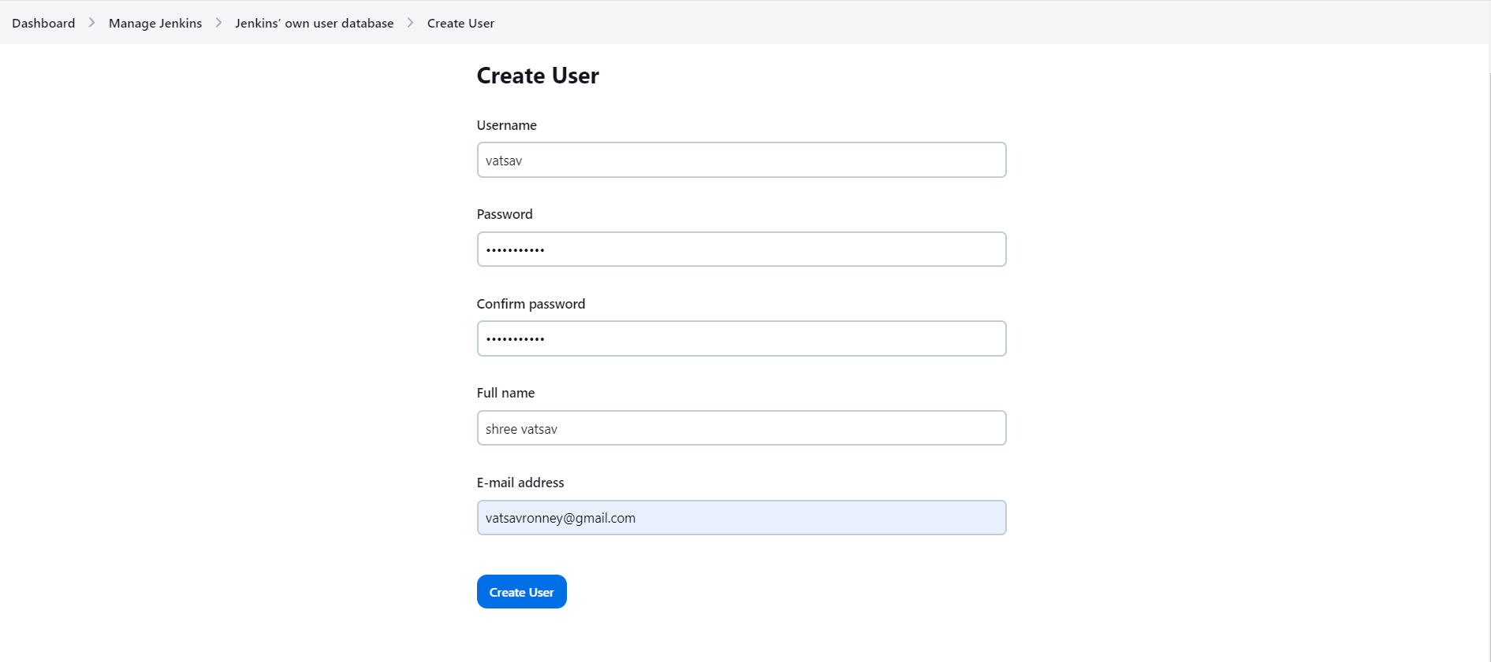

**USER CREATED**

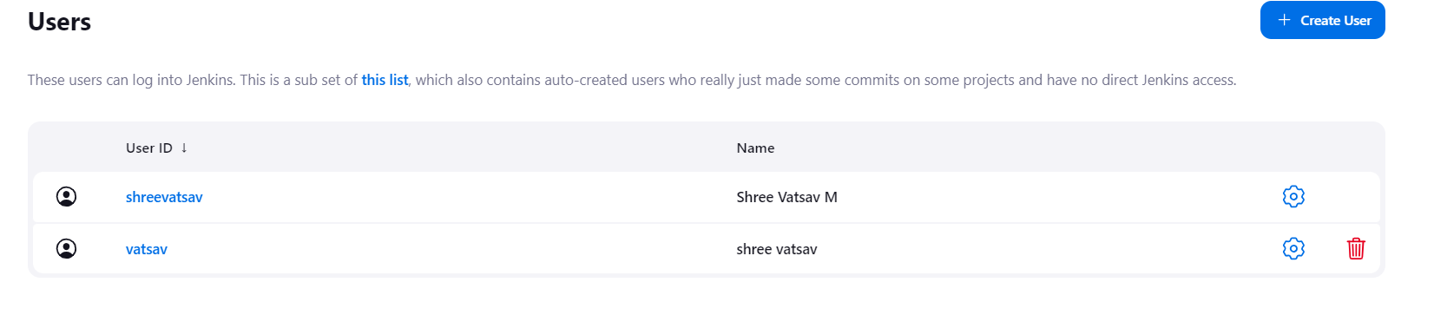

**BUILD**

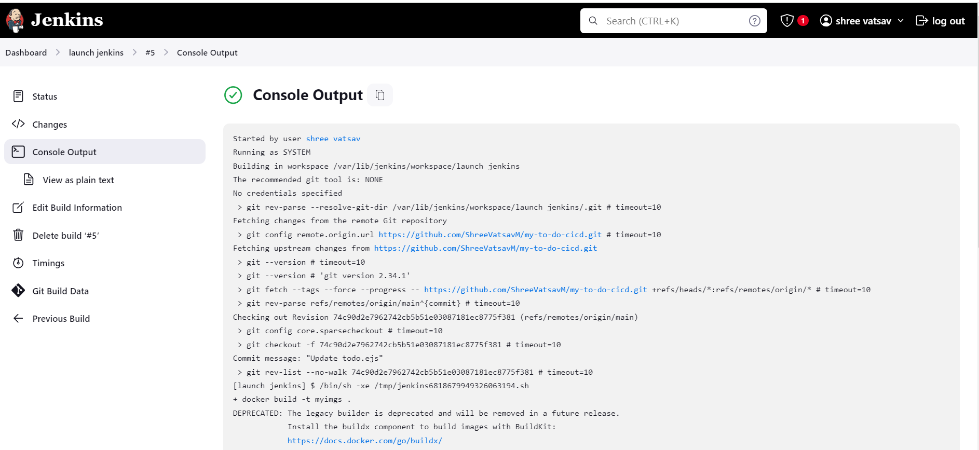

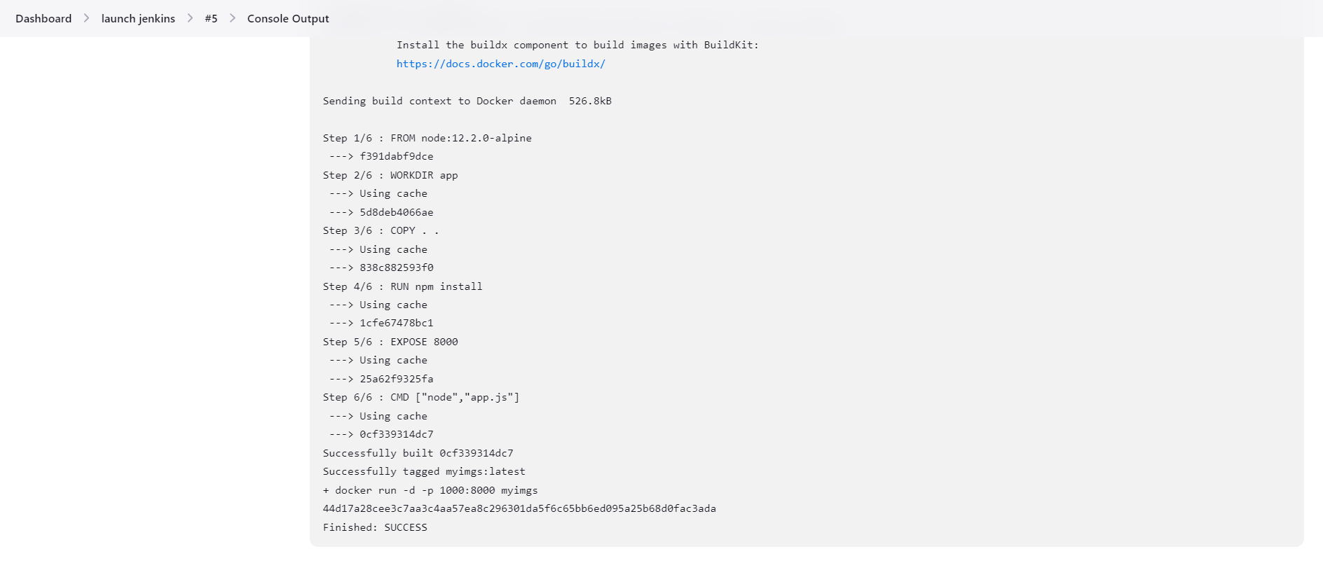

**OUTPUT**

